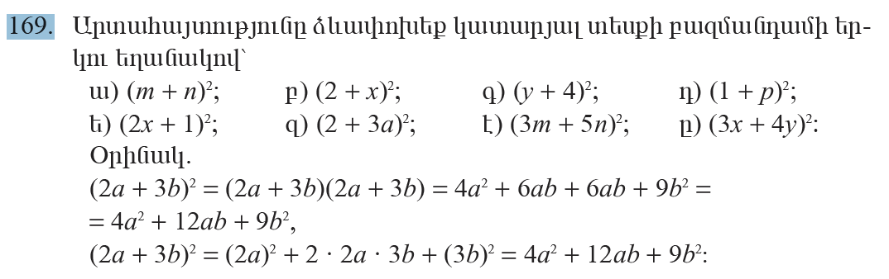
ա)(m + n)² = m² + 2mn + n²
բ)(2 + x)² = 4 + 4x + x²
գ)(y + 4)² = y² + 8y + 16
դ)(1 + p)² = 1 + 2p + p²
ե)(2x + 1)² = 4x² + 4x + 1
զ)(2 + 3a)² = 4 + 6a + 9a²
է)(3m + 5n)² = 9m + 30mn+ 25n²
ը)(3x + 4y)² = 9x² + 24xy + 16y²

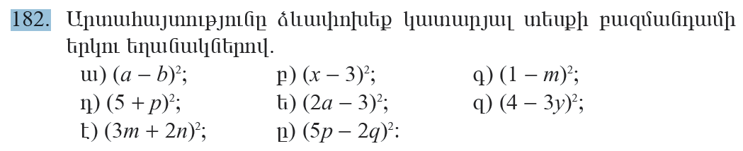
ա)(a – b)² = a² – 2ab + b²
բ)(x – 3)² = x² – 6x + 9
գ)(1 – m)² = 1 – 2m + m²
դ)(5 + p)² = 25 + 10p + p²
ե)(2a – 3)² = 4a² – 12a + 9
զ)(4 – 3y)² = 16 - 24y + 9y²
է)(3m + 2n)² = 9m² + 12mn + 4n²
ը)(5p – 2q)² = 25p² – 20pq + 4q²
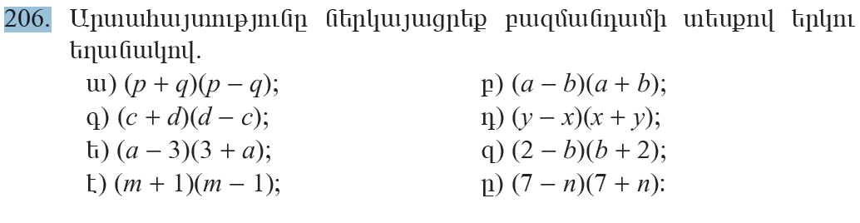
ա)(p + q)(p – q) = p² – q²
բ)(a – b)(a + b) = a² – b²
գ)(c + d)(d – c) = c² – d²
դ)(y – x)(x + y) = y² – x²
ե)(a – 3)(a + 3) = a² – 9
զ)(2 –b)(b + 2) = 4 – b²
է)(m + 1)( m – 1) = m² – 1
ը)(7 – n)(7 + n) =49 – n²
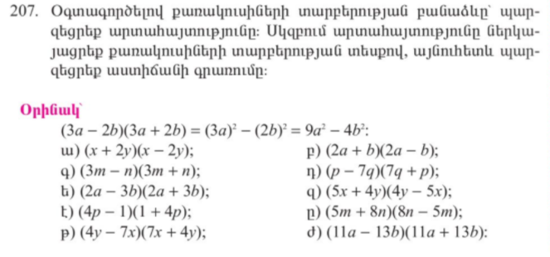
ա)(x + 2y)(x - 2y) = x² – 4y²
բ)(2a + b)(2a – b) = 4a² – b²
գ)(3m – n)(3m + n) =9m² - n²
դ)(p – 7q)(7q + p) = p² – 49q²
ե)(2a – 3b)(2a + 3b) = 4a² – 9b²
զ)(5x + 4y)(4y – 5x) = 25x² – 16y²
է)(4p – 1)(1 + 4p) = 16p² – 1
ը)(5m + 8n)(8n – 5m) = 25m² – 64n²
թ)(4y – 7x)(7x + 4y) = 16y² – 49x²
ժ)(11a – 13b)(11a + 13b) = 121² – 169b²
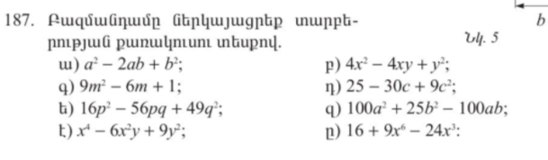
ա)a² – 2ab + b² = (a – b)²
բ)4x² – 4xy + y² = (2x – y)²
գ)9m² – 6m + 1 = (3m – 1)²
դ)25 – 30c + 9c² = (5 – 3c)²
ե)16p² – 56pq + 49q² = (4p – 7q)²
զ)100a² + 25b² – 100ab = (10a – 5b)²
է)x⁴ – 6x²y + 9y² = (x² – 3y)²
ը)16 + 9x⁶ – 24x³ = (4 – 3x³)²
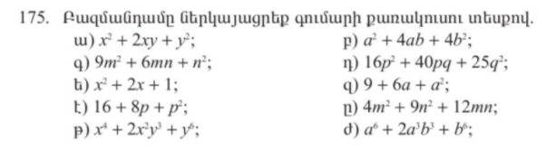
ա)x² + 2xy + y² = (x + y)²
բ)a² + 4ab + 4b² = (a + 2b)²
գ)9m² + 6mn + n² = (3m + n)²
դ)16p² + 40pq + 25q² = (4p + 5q)²
ե)x² + 2x + 1 = (x + 1)²
զ)9 + 6a + a² = (3 + a)²
է)16 + 8p + p² = (4 + p)²
ը)4m² + 9n² + 12mn = (2m + 3n)²
թ)x⁴ + 2x²y³ + y⁶ = (x² + y³)²
ժ)a⁶ + 2a³b³ + b⁶ = (a³ + b³)²

