Գտեք
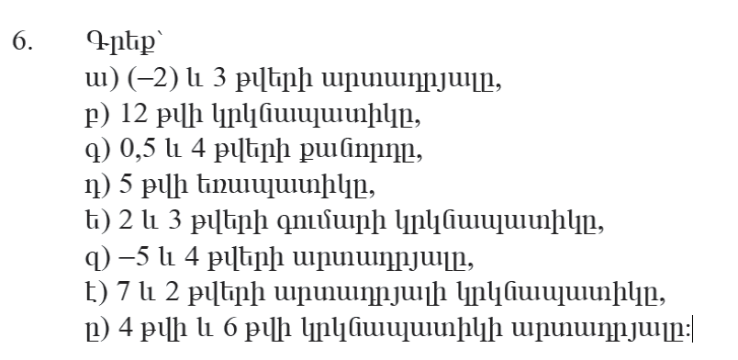
Ա — -6
Բ— 24
Գ — 5/10
Դ — 15
Ե — 10
Զ — -20
Է — 28
Ը — 96
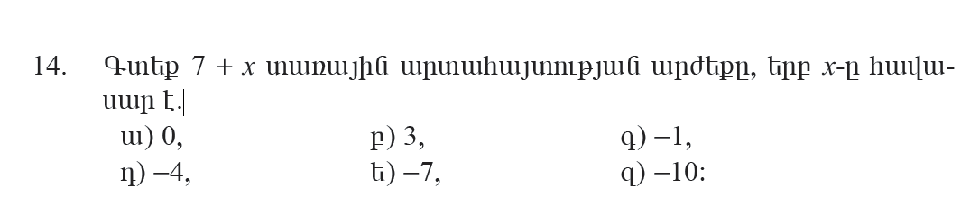
Ա — 7 + 0 = 7
Բ — 7 + 3 = 10
Գ — 7 + (-1) = 6
Դ — 7 + (-4) = 3
Ե —7 + (-7) = 0
Զ – 7 + (-10) = -3
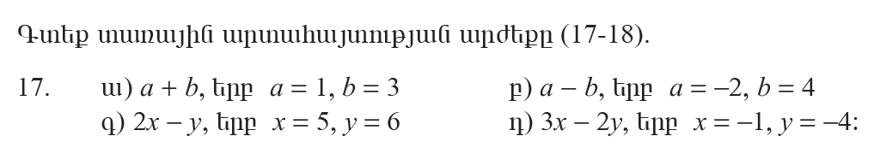
Ա — 1 + 3 = 4
Բ — -2 – 4 = -6
Գ – 2 * 5 – 6 = 4
Դ – 3 * 1 – (-2) * -4 = 5

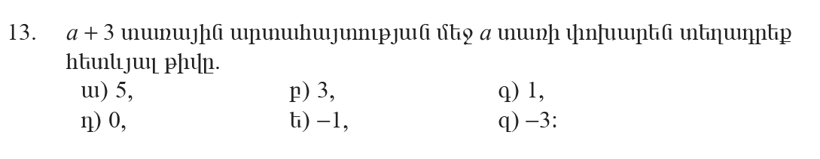
Ա — 5 + 5 = 10
Բ — 5 + 3 = 8
Գ — 3 + 1 = 4
Դ — 3 + 0 = 3
Ե – 3 + (-1) = 2
Զ – 3 + (-3) = 6

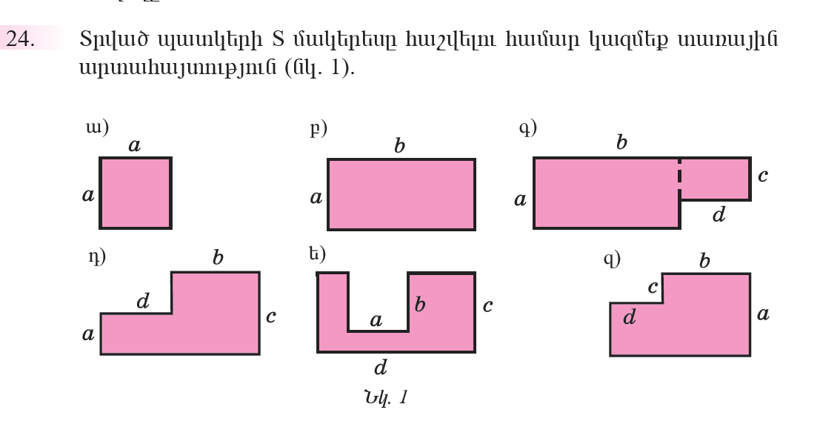
Ա — a * a
Բ — a * b
Գ — (a * b) + (d + c)
Դ —(c * b) + (a * d)
Ե — (b * c) + (b * c) : 2 + (a * a)
Զ — (d * d) + (b * a)

