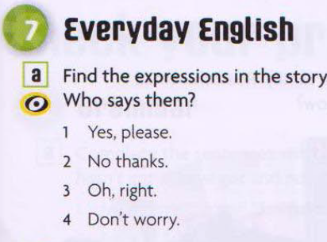 Page - 51
a.1)Izzie – Yes, pleas.
2)Kate – No thanks.
3)Mark – Oh, right.
4)Mark – Don`t worry.

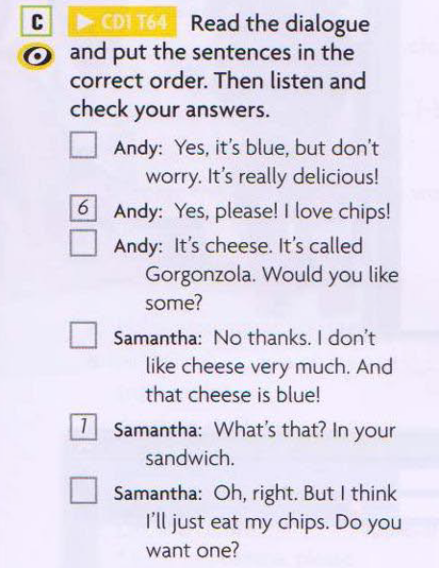
- What`s that? In your sandwich.
- It`s cheese.It`s called Gorgonzola. Would you like some?
- No thanks. I don`t like cheese very much. And that cheese is blue.
- Yes, It`s blue, but don`t worry, It`s really delicious.
- Oh, right.But i think i`ll just my chips.Do you want one?
- Yes please! I love chips!.
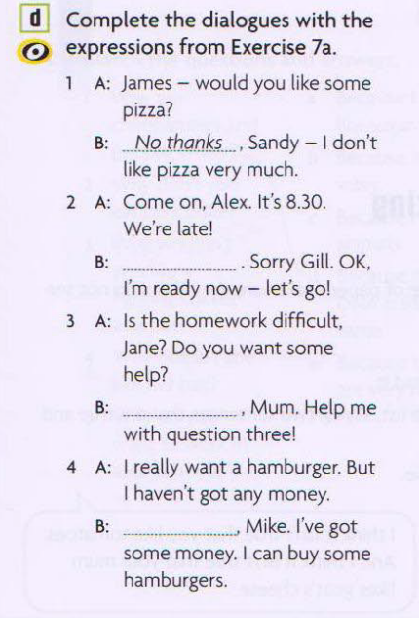
1.A)James – would you like some pizza?
B)No thanks, Sandy – I don`t like pizza very much.
2.Come on, Alex. It`s 8.30..Were late.
Oh right .Sorry Gill, Ok, I`m ready now – let`s go!
3)A)Is the homework difficult, Jane? Do you want some help?
B)Yes please. Mum. Help me with question three.
4)A)I really want a hamburger. But I haven`t got any money.
b)Don’t worry, Mike. I`ve got some money. I can buy some hamburgers.
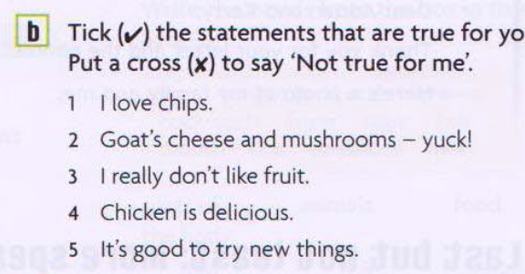
- I love chips (True for me).
- Goat`s cheese and mushrooms – yuck! (Not true for me).
- I really don`t like fruit (Not true for me).
- Chicken is delicious (True for me).
- It`s good to try new things (True for me).

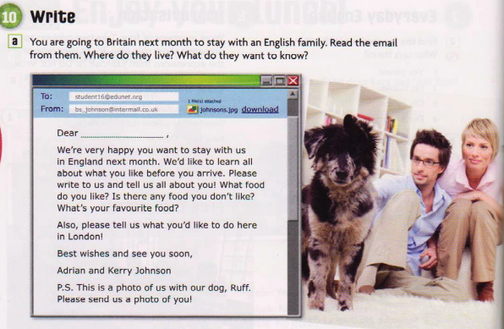 52 page

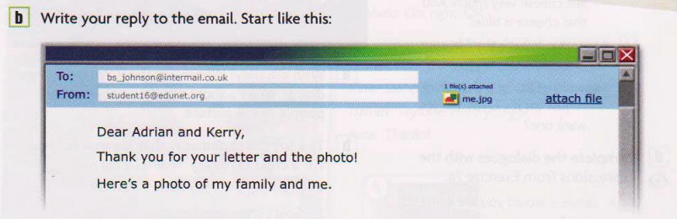
Hello, thank you for letter.
Now I tell you about me. I love food and I didn`t have favorite food. I didn`t love spinach.
In London I wanted see Big Ben, I want see two floor buses etc.

Page 53 ( Check your progress)
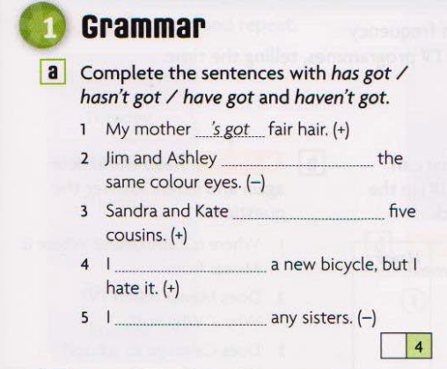
1 My mother`s got fair hair.
2 Jim and Ashley haven`t got the same colour eyes.
3 Sandra and Kate have got five cousins
4 I have got a new bicycle, but i hate it.
5 I haven`t got any sisters.
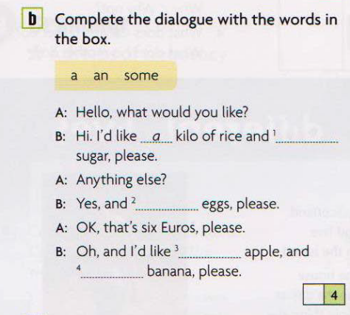
A: Hello, what would you like?
B:Hi.I`d like a kilo of rice and some sugar, please.
A:Anything else.
B:Yes, and some eggs, please.
A: OK, that`s six Euros, pleas.
Oh, and i`d like an apple, and a banana, please.
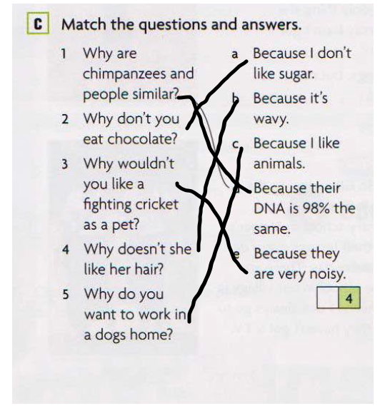
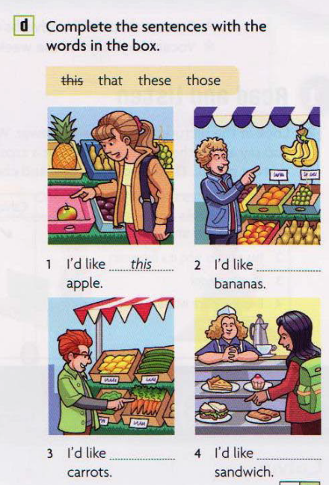
1 I`d like this apple.
2 I`d like these bananas.
3 I`d like those carrots.
4 I`d like that sandwich.

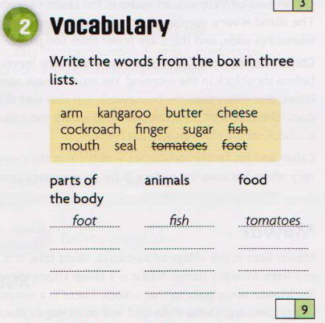
Parts of the body – foot, arm, finger, mouth
Animals – fish, kangaroo, cockroach,
Food – butter, cheese, sugar, tomatoes.

